2020 Employee Campaign Chair
Social Media & Email Marketing Sample Templates

Email Template Examples
Subject Line: Join the movement with United Way
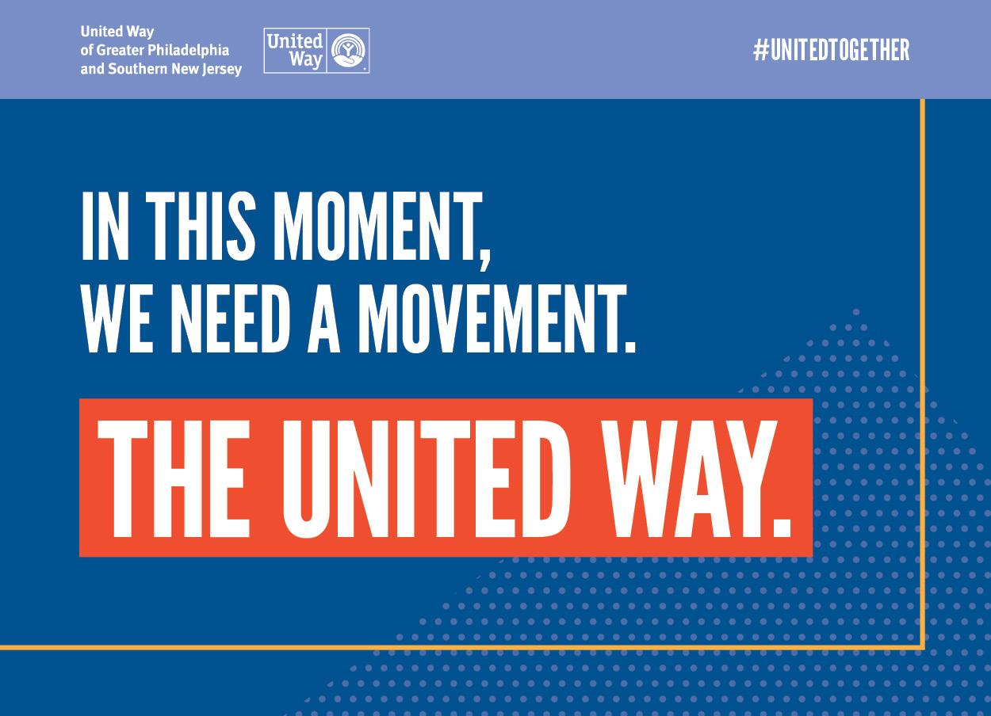
Dear [First Name],
In our region, more than 705K individuals – including 222K+ children – live in poverty.
Poverty traps families for generations and limits our children before they even have a chance to succeed. Together, we can change this.
We’ve all seen the devastating effects that COVID-19 is having in our local communities, further deepening the inequalities and racial disparities across the country. This is why [Insert Company Name], is joining United Way’s fight to meaningfully and measurably reduce poverty in our region and expand opportunity for all.
As our region’s largest philanthropic partner, United Way works to address the toughest challenges in local communities throughout Greater Philadelphia and Southern New Jersey. Through strong partnerships and new solutions, United Way tackles the problems that no one can solve alone. It’s what makes United Way unique: that although it operates around the world, each local United Way leverages their volunteers and resources to support, fund and convene local partners who are committed to driving meaningful LOCAL change.
Our local United Way is on a mission to reduce poverty in our region. Children succeed when their parents succeed, that’s why United Way is focused on a 2-generation approach that builds youth success and stable individuals and families.
I hope that you’ll consider a contribution to United Way during our campaign – in particular, to United Way’s Impact Fund. This year, our goal is to raise [Insert Dollar Amount] and [Insert Additional Goals if Applicable].
Click here to make your donation online and join the movement for a better tomorrow for all. (This is a unique, confidential link only for you.)
Our United Way campaign will run from [Insert Date]-[Insert Date].
To celebrate the conclusion of our campaign and our inevitable success, please hold [Insert Date] for an End of Campaign Celebration. A formal calendar invitation will follow.] You have the power to create change. [Insert detail about the impact of a gift – 1 person whole company].
Thank you for all you do for [Insert Company Name] and for our neighbors in need.
Sincerely,
[Insert CEO signature]

Subject Line: Your gift helps change lives
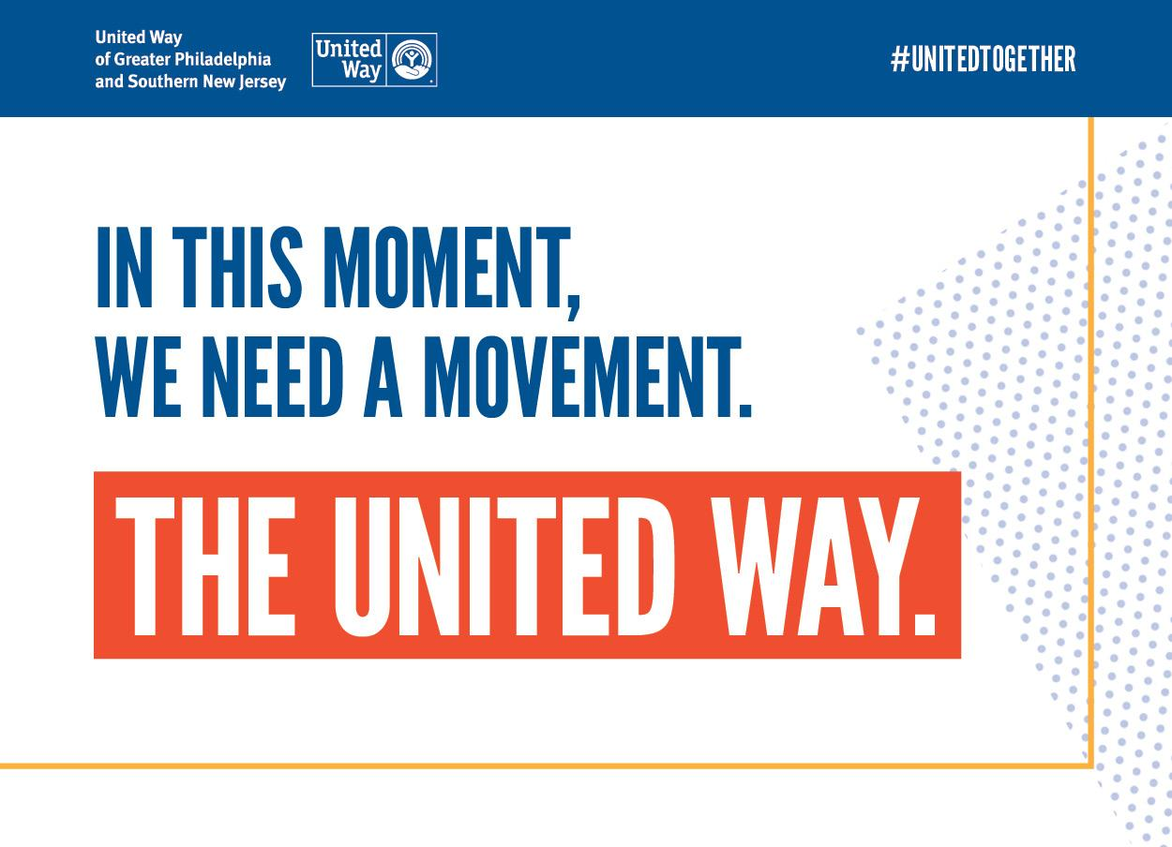
Dear [First Name],
With your gift to our United Way campaign, you have the opportunity to be extraordinary and make a difference for people like Ameesha and Amari.

A single mother raising her 4 year old son, Ameesha connected with Parent Child Plus, an organization that provides home-based training and resources that equip parents to prepare their youngsters to start school ready to learn. The organization is part of United Way’s focus on reducing poverty and giving kids the foundation they need to succeed in school and stay on track to a lifetime of possibility.
“The best part was that we both got something out of it. He flourished and I learned how to help empower that part of him. I learned to encourage him, how to slow down and let him set the pace so he’s in the best position to learn.”
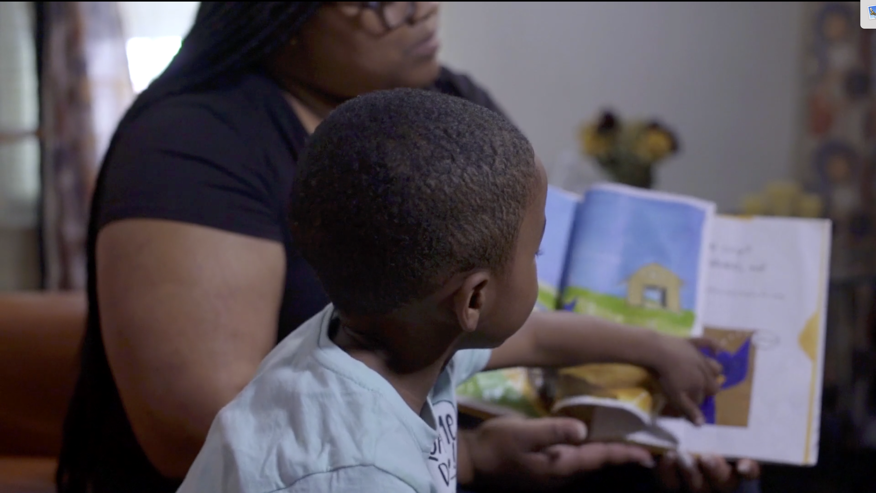
When you invest in United Way’s Impact Fund, you help break the cycle of poverty. Initiatives like the Parent Child Plus program are made possible through your support and generosity. When you help a child read on grade level by the end of third grade, you give them a better chance to graduate high school. When you help a 16-year-old complete their GED or a 22-year-old hold a steady job, you give them the tools for success and help them stay out of trouble. When you help a family overcome poverty, you give their children a brighter future and strengthen our community for the long term.
Last year, we raised more than [Insert Dollar Amount if applicable] during our United Way campaign. As of today, we’ve raised $X and are X% of the way to our goal of $X. To make your donation now, click here.
Thank you in advance for your support and for choosing to LIVE UNITED!
Sincerely,
[Insert names of campaign committee]

Email Response Example

Subject Line: Thank You for fighting poverty with us
Dear [First Name],
Because of you, we were able to raise [Insert Dollar Amount] to help meaningfully and measurably reduce poverty and make sure children, individuals and families across our region have the resources they need to succeed. Additionally, [insert other key results such as participation rate, number of leadership donors, etc.].
On behalf of myself and the Campaign Committee here at [Company Name], thank you for your support and dedication to United Way’s mission to expand opportunity for all. We are so proud of our achievements and look forward to another great campaign next year!

Warm regards,
[Insert CEO signature and names of campaign committee]

Social Media Examples
*Additional Social Media Visual Assets Coming Soon

Company Posts

[CompanyName] is proud to launch this year’s #UnitedWay campaign! Funds raised will help reduce poverty in our communities and aid those affected by COVID-19. Learn more here [Campaign Link] #unitedtogether
We need your support! This years United Way campaign aims to help those affected by #Coronavirus and deep poverty. Join the movement by visiting [Campaign Landing Page] @PhillysjUnited #unitedtogether
We are joining our partners @Phillysjunited to raise [Campaign goal] for this year’s #UnitedWay campaign. Why? Because by working together, we can build a stronger, more equitable future. When our neighbors thrive, we all thrive. #unitedtogether
When you give to United Way, you make a difference in measurably and meaningfully reducing poverty in our area. That’s why we’re excited to announce our kickoff to this year's campaign to raise [Campaign Goal]! Join the movement here [Campaign Link] #unitedtogether

Individual Employee Posts

I am joining the #movement! Together with @Phillysjunited and [Company Twitter Handle] I am helping to raise [Campaign Goal] to reduce #poverty in my local community! Learn more here [Custom Campaign Landing Page Link] #unitedtogether

With so many in need right now, I am happy to join in [Company Name]’s campaign with @Phillysjunited. Why? Reducing #poverty in our region is needed now more than ever. We are #unitedtogether [Campaign Link]

Proud to work for [Company Name] who is joining forces with @Phillysjunited to help reduce #poverty in #Philly #PA and #SouthJersey! Our campaign is raising [Campaign Goal] to help combat the complex issues our local communities face. #unitedtogether [Campaign Link]

Intranet Example

Hello [Insert Company Name] Family,
We hope you join us in excitement for this year's United Way campaign which will run from [Insert Date]-[Insert Date]. It’s no secret that our fellow neighbors need help now more than ever during these unprecedented times. This year, our goal is to raise [Insert Dollar Amount] and [Insert Additional Goals if Applicable] which will help to meaningfully and measurably reduce poverty in our region. Achieving that goal takes a village and that’s why we’ve joined forces with our local United Way.
For this year's campaign WE NEED YOU. We need your dedication, enthusiasm, and most of all your compassion to do for others. There is no option to standby while surrounding communities and fellow neighbors struggle, and we must all do our part for a better future for all.
As our region’s largest philanthropic partner, our local United Way works to address the toughest challenges in our communities.
We encourage you to learn more about and get involved in this years United Way Campaign. In this moment, we join the movement for a better tomorrow.
Click here to join the movement and make your donation online now. [Insert Campaign Link]

