Localized 2018-19 Sample E-Pledge Messages
Subject Line: Join us in our fight to end poverty with United Way
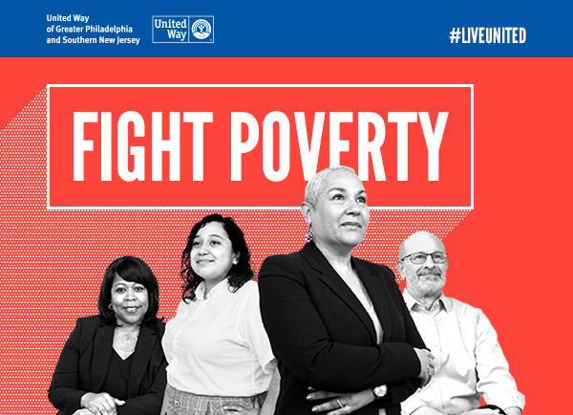
Dear [First Name],
In our region, more than 705K individuals – including 222K+ children – live in poverty.
Poverty traps families for generations and limits our children before they even have a chance to succeed…BUT together, we can change this.
At [Insert Company Name], we are joining United Way’s fight to end poverty in our region – and we hope you stand with us!
As our region’s largest philanthropic partner, United Way works to address the toughest challenges in local communities throughout the Greater Philadelphia and Southern New Jersey area. Through strong partnerships, seeking new solutions to old problems, and mobilizing the best resources and the most inspired supporters, United Way tackles the problems that no one can solve alone. It’s what makes United Way unique: that although it operates around the world, each local United Way leverages their volunteers and resources to support, fund and convene local partners who are committed to driving meaningful, impactful, LOCAL change.
Our local United Way is on a mission to end poverty in our region. Children succeed when their parents succeed, that’s why United Way is focused on 2-generation approach that builds youth success and stable individuals and families.

With your support of United Way’s Impact Fund, together, by 2030:
- 90% of children will read on grade level by the end of 3rd grade
- 50K youth aged 15-25 will reconnect to school or work (we will prevent 16,000 from disconnecting)
- And 300K individuals will overcome poverty (and we will prevent 300K more from slipping into its cycle)

I hope you’ll consider a contribution to United Way during our campaign – in particular, to United Way’s Impact Fund.

This year, our goal is to raise [Insert Dollar Amount] and [Insert Additional Goals if Applicable].
Click here to make your donation online now. (This is a unique, confidential link only for you.)
Our United Way campaign will run from [Insert Date]-[Insert Date].
[To celebrate the conclusion of our campaign and our inevitable success, please hold [Insert Date] for an End of Campaign Celebration. A formal calendar invitation will follow.]
You have the power to create change. [Insert detail about the impact of a gift – 1 person whole company].
Thank you for all you do for [Insert Company Name] and for our neighbors in need!
Sincerely,
[Insert CEO signature]

Subject Line: With your gift, you help change lives
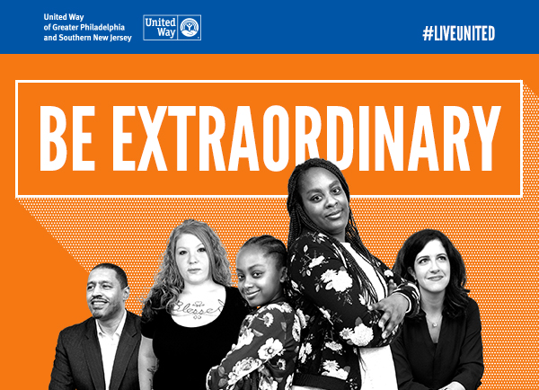
Dear [First Name],
With your gift to our United Way campaign, you have the opportunity to be extraordinary and make a difference for people like Lillian and her daughter.
A single mother trying to make ends meet, Lillian faced eviction after owing thousands of dollars in unpaid utility bills that she desperately tried to pay down. She enrolled in United Way’s Siemer Institute for Family Stability (SIFS), which focuses on helping local families become, and remain, stable. Through a combination of financial assistance, budget coaching, job training and more, Lillian and her daughter are thriving.
“I know I can stand on my own and help my daughter build a brighter future.” – Lillian, Proud Program Graduate
Did you know 1 in 2 children born into poverty will remain poor for a lifetime? We know that children succeed when their parents succeed and with your gift to the Impact Fund, Lillian’s daughter and other children like her have the opportunity to go farther in life and pursue their dreams.
When you invest in United Way’s Impact Fund, you help break the cycle of poverty.
When you help a child read on grade level by the end of third grade, you give her a better chance to graduate high school.
When you help a 16-year-old complete his GED or a 22-year-old hold a steady job, you give him tools for success and help him stay out of trouble.
When you help a family overcome poverty, you give their children a brighter future and strengthen our community for the long term.
Last year, we raised more than [Insert Dollar Amount if applicable] during our United Way campaign. As of today, we’ve raised $X and are X% of the way to our goal of $X. To make your donation now, click here.

Thank you in advance for your support and for choosing to LIVE UNITED!

Sincerely,
[Insert names of campaign committee]

Subject Line: Thank You for fighting poverty with us
Dear [First Name],
Because of you, we were able to raise [Insert Dollar Amount] to help end poverty and make sure children, individuals and families across our region have the resources they need to succeed. Additionally, [insert other key results such as participation rate, number of leadership donors, etc.].
On behalf of myself and the Campaign Committee, thank you for your support and dedication to United Way’s cause: ending intergenerational poverty. We are so proud of our achievements and look forward to another great campaign next year!
Warm regards,
[Insert CEO signature and names of campaign committee]

